**Reports/ View Visits State Diagram**

The initial state begins under the impression that the user has appropriate access to reach this screen in PAS. The user has the option to update the table either by choosing a new date range, or by selecting a column header to sort the data by that column. At this point new data is displayed.

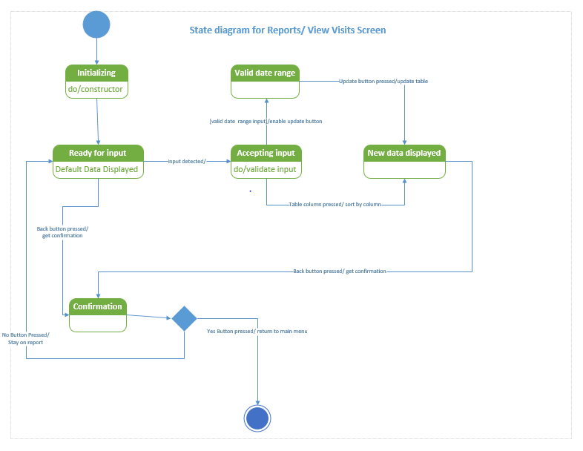 The user can choose to click the back button at any time which will cause a confirmation message to pop up. If the user selected no, the message will close and the view visits screen will still be visible. If the user selects yes, they will return to the main menu.